Assignment 1

K.Saketh Sai Nigam 22201204

2022-09-27

## Task 1: Manipulation

#1. Load the dataset EurostatCrime2019.csv. Notice that the first column of the csv filecontains the names of the countries that must be read as row names [Hint: Load in the file using the function read.csv].  
  
#Loading the dataset  
D <- read.csv("/Users/saketh/Desktop/R /Ass1/EurostatCrime2019.csv",row.names = 'X')   
  
#2.What is the size (number of rows and columns) and the structure of this dataset?   
  
#No:of Rows of Dataset 'D'  
print(nrow(D))

## [1] 41

#No:of Columns of Dataset 'D'  
print(ncol(D))

## [1] 13

#Structure of Dataset 'D'  
print(str(D))

## 'data.frame': 41 obs. of 13 variables:  
## $ Intentional.homicide : num 2.03 0.84 1.27 NA 1.14 0.81 1.48 0.76 0.91 NA ...  
## $ Attempted.intentional.homicide : num 3.25 1.93 8.87 NA 0.54 2.4 1.71 0.58 2.57 NA ...  
## $ Assault : num 5.52 43.29 556.36 NA 39.54 ...  
## $ Kidnapping : num 0.14 0.07 NA NA 1.03 0.02 0.91 0.11 NA NA ...  
## $ Sexual.violence : num 5.38 50.9 77.45 NA 8.64 ...  
## $ Rape : num 2.69 18.92 33.33 NA 1.87 ...  
## $ Sexual.assault : num 2.69 26.64 44.12 NA NA ...  
## $ Robbery : num 3.42 29.67 140.14 NA 16.9 ...  
## $ Burglary : num NA 613.2 565.9 NA 79.8 ...  
## $ Burglary.of.private.residential.premises : num 40.4 99.3 410.1 NA NA ...  
## $ Theft : num 169 1303 1952 NA 474 ...  
## $ Theft.of.a.motorized.land.vehicle : num 11.1 44.2 109.8 NA 18.9 ...  
## $ Unlawful.acts.involving.controlled.drugs.or.precursors: num 70.3 494.1 547.7 NA 78.1 ...  
## NULL

#3.(i) For most countries sexual violence figures are the sum of rape and sexual assault. Remove the columns Rape and Sexual.assault.  
  
#Removing the columns Rape and Sexual.assault.  
D <- subset(D,select = -c(Rape,Sexual.assault))  
head(D)

## Intentional.homicide Attempted.intentional.homicide  
## Albania 2.03 3.25  
## Austria 0.84 1.93  
## Belgium 1.27 8.87  
## Bosnia and Herzegovina NA NA  
## Bulgaria 1.14 0.54  
## Croatia 0.81 2.40  
## Assault Kidnapping Sexual.violence Robbery Burglary  
## Albania 5.52 0.14 5.38 3.42 NA  
## Austria 43.29 0.07 50.90 29.67 613.22  
## Belgium 556.36 NA 77.45 140.14 565.92  
## Bosnia and Herzegovina NA NA NA NA NA  
## Bulgaria 39.54 1.03 8.64 16.90 79.81  
## Croatia 18.06 0.02 21.05 20.56 265.73  
## Burglary.of.private.residential.premises Theft  
## Albania 40.42 168.84  
## Austria 99.31 1302.92  
## Belgium 410.12 1951.96  
## Bosnia and Herzegovina NA NA  
## Bulgaria NA 473.88  
## Croatia 78.53 291.00  
## Theft.of.a.motorized.land.vehicle  
## Albania 11.11  
## Austria 44.22  
## Belgium 109.76  
## Bosnia and Herzegovina NA  
## Bulgaria 18.87  
## Croatia 25.42  
## Unlawful.acts.involving.controlled.drugs.or.precursors  
## Albania 70.26  
## Austria 494.05  
## Belgium 547.74  
## Bosnia and Herzegovina NA  
## Bulgaria 78.14  
## Croatia 272.16

#3.(ii) For some countries Theft includes also burglary, and theft of motorised land vehicle, in others they are recorded separately. In order to compare the different countries, remove the columns involving theft and burglary: 1.Theft,2. Theft.of.a.motorized.land.vehicle,3. Burglary,4. Burglary.of.private.residential.premises.  
  
#Removing the columns Theft,Theft.of.a.motorized.land.vehicle,Burglary,Burglary.of.private.residential.premises.  
D <- subset(D,select = -c(Theft,Theft.of.a.motorized.land.vehicle,Burglary,Burglary.of.private.residential.premises))  
head(D)

## Intentional.homicide Attempted.intentional.homicide  
## Albania 2.03 3.25  
## Austria 0.84 1.93  
## Belgium 1.27 8.87  
## Bosnia and Herzegovina NA NA  
## Bulgaria 1.14 0.54  
## Croatia 0.81 2.40  
## Assault Kidnapping Sexual.violence Robbery  
## Albania 5.52 0.14 5.38 3.42  
## Austria 43.29 0.07 50.90 29.67  
## Belgium 556.36 NA 77.45 140.14  
## Bosnia and Herzegovina NA NA NA NA  
## Bulgaria 39.54 1.03 8.64 16.90  
## Croatia 18.06 0.02 21.05 20.56  
## Unlawful.acts.involving.controlled.drugs.or.precursors  
## Albania 70.26  
## Austria 494.05  
## Belgium 547.74  
## Bosnia and Herzegovina NA  
## Bulgaria 78.14  
## Croatia 272.16

#3.(iii) Add a column containing the overall record of offences for each country (per hundred thousand inhabitants)?  
  
#Creating the column called OverAllRecords  
D$OverAllRecords = D$Intentional.homicide+D$Attempted.intentional.homicide+D$Assault+D$Kidnapping+D$Sexual.violence+D$Robbery+D$Unlawful.acts.involving.controlled.drugs.or.precursors  
head(D)

## Intentional.homicide Attempted.intentional.homicide  
## Albania 2.03 3.25  
## Austria 0.84 1.93  
## Belgium 1.27 8.87  
## Bosnia and Herzegovina NA NA  
## Bulgaria 1.14 0.54  
## Croatia 0.81 2.40  
## Assault Kidnapping Sexual.violence Robbery  
## Albania 5.52 0.14 5.38 3.42  
## Austria 43.29 0.07 50.90 29.67  
## Belgium 556.36 NA 77.45 140.14  
## Bosnia and Herzegovina NA NA NA NA  
## Bulgaria 39.54 1.03 8.64 16.90  
## Croatia 18.06 0.02 21.05 20.56  
## Unlawful.acts.involving.controlled.drugs.or.precursors  
## Albania 70.26  
## Austria 494.05  
## Belgium 547.74  
## Bosnia and Herzegovina NA  
## Bulgaria 78.14  
## Croatia 272.16  
## OverAllRecords  
## Albania 90.00  
## Austria 620.75  
## Belgium NA  
## Bosnia and Herzegovina NA  
## Bulgaria 145.93  
## Croatia 335.06

#4. Work with the dataset you just created, and list the countries that contain any missing data  
  
#Printing the countries which have the missing data  
CountriesOfMissingData <- names(which(rowSums(is.na(D))>0))   
print(CountriesOfMissingData)

## [1] "Belgium" "Bosnia and Herzegovina" "Denmark"   
## [4] "England and Wales" "Estonia" "France"   
## [7] "Hungary" "Iceland" "Liechtenstein"   
## [10] "Netherlands" "North Macedonia" "Northern Ireland (UK)"   
## [13] "Norway" "Poland" "Portugal"   
## [16] "Scotland" "Slovakia" "Sweden"   
## [19] "Turkey"

#5. Remove the countries with missing data from the dataframe.  
  
#Removing the countries which have misssing data from the Dataset 'D'  
D <- D[!(row.names(D) %in% CountriesOfMissingData),]  
head(D)

## Intentional.homicide Attempted.intentional.homicide Assault Kidnapping  
## Albania 2.03 3.25 5.52 0.14  
## Austria 0.84 1.93 43.29 0.07  
## Bulgaria 1.14 0.54 39.54 1.03  
## Croatia 0.81 2.40 18.06 0.02  
## Cyprus 1.48 1.71 20.09 0.91  
## Czechia 0.76 0.58 43.98 0.11  
## Sexual.violence Robbery  
## Albania 5.38 3.42  
## Austria 50.90 29.67  
## Bulgaria 8.64 16.90  
## Croatia 21.05 20.56  
## Cyprus 1.94 6.28  
## Czechia 14.65 13.51  
## Unlawful.acts.involving.controlled.drugs.or.precursors OverAllRecords  
## Albania 70.26 90.00  
## Austria 494.05 620.75  
## Bulgaria 78.14 145.93  
## Croatia 272.16 335.06  
## Cyprus 117.82 150.23  
## Czechia 45.25 118.84

#6. How many observations and variables are in this new dataframe?  
  
#No:of Rows of new Dataset 'D'  
print(nrow(D))

## [1] 22

#No:of Columns of new Dataset 'D'  
print(ncol(D))

## [1] 8

#Structure of new Dataset 'D'  
print(str(D))

## 'data.frame': 22 obs. of 8 variables:  
## $ Intentional.homicide : num 2.03 0.84 1.14 0.81 1.48 0.76 1.59 0.71 0.71 0.71 ...  
## $ Attempted.intentional.homicide : num 3.25 1.93 0.54 2.4 1.71 0.58 5.96 2.18 1.09 0.55 ...  
## $ Assault : num 5.52 43.29 39.54 18.06 20.09 ...  
## $ Kidnapping : num 0.14 0.07 1.03 0.02 0.91 0.11 0.02 5.44 0.66 1.71 ...  
## $ Sexual.violence : num 5.38 50.9 8.64 21.05 1.94 ...  
## $ Robbery : num 3.42 29.67 16.9 20.56 6.28 ...  
## $ Unlawful.acts.involving.controlled.drugs.or.precursors: num 70.3 494.1 78.1 272.2 117.8 ...  
## $ OverAllRecords : num 90 621 146 335 150 ...  
## NULL

## Task 2: Analysis

#1. According to these data what were the 3 most common crimes in Ireland in 2019?  
D1<-D[(row.names(D) %in% "Ireland"),]  
D1<-t(D1)  
D2<-data.frame(D1[rev(order(as.numeric(as.character(D1)))), ,drop=FALSE])  
D3<-D2[-c(1:2),,drop = FALSE]  
  
#The Three most common crimes in Ireland   
row.names(D3[c(1:3),,drop = FALSE])

## [1] "Assault" "Sexual.violence" "Robbery"

#2. What proportion of the overall crimes was due to Assault in Ireland in 2019?  
  
D["Ireland","Assault"]/D["Ireland","OverAllRecords"]

## [1] 0.1605316

#3. Which country had the highest record of kidnapping in 2019 (per hundred thousand inhabitants)?  
  
HigestRecordOfKidnapping <- D[order(-D$Kidnapping),,drop = FALSE]   
row.names(HigestRecordOfKidnapping)[1]

## [1] "Luxembourg"

#4. Which country had the lowest overall record of offences in 2019 (per hundred thousand inhabitants)?  
   
LowestOfOverAllRecords<-D[order(-D$OverAllRecords), , drop = FALSE]  
  
row.names(LowestOfOverAllRecords)[length(row.names(LowestOfOverAllRecords))]

## [1] "Romania"

#5. Create a plot displaying the relationship between robbery and unlawful acts involving controlled drugs or precursors. Make the plot look “nice” i.e. change axis labels etc.?  
  
plot(D$Robbery,D$Unlawful.acts.involving.controlled.drugs.or.precursors,main="Robbery vs. Unlawful acts involving controlled drugs or precursors",xlab="Robbery", ylab="Unlawful acts involving controlled drugs or precursors",col="navy",pch=20)  
axis(side = 1, at = seq(0, 140, by = 5), labels = FALSE)

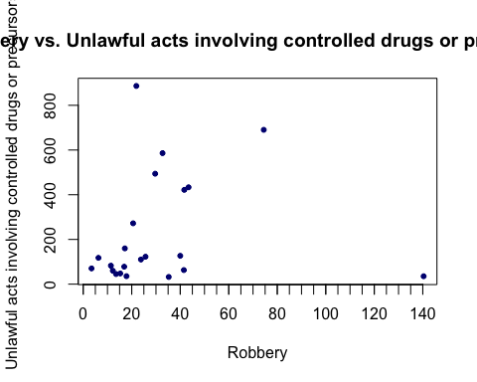

## Task 3: Creativity

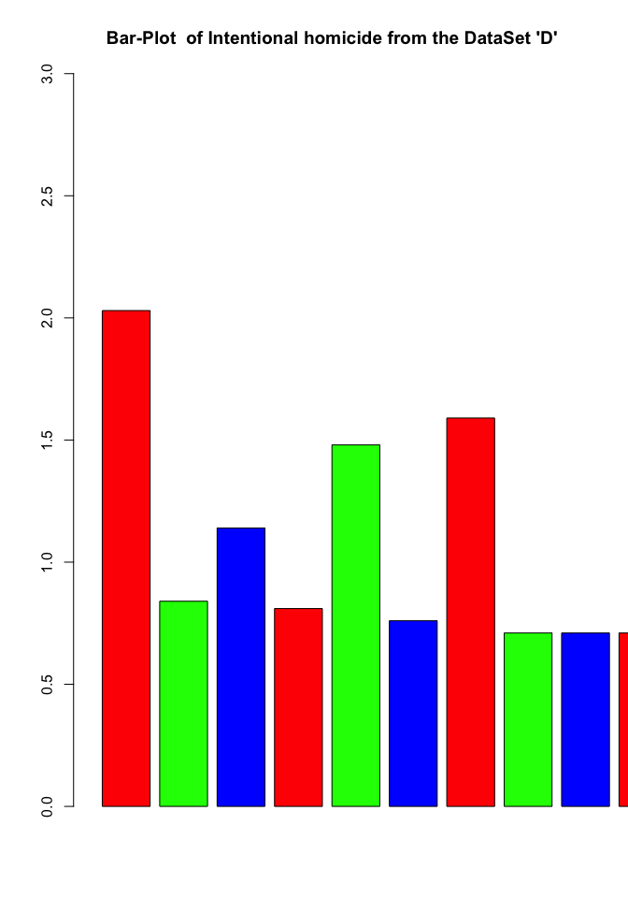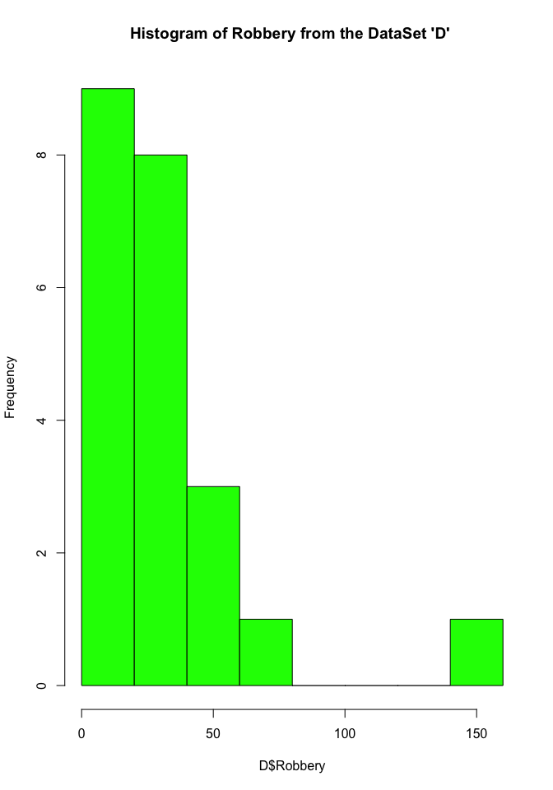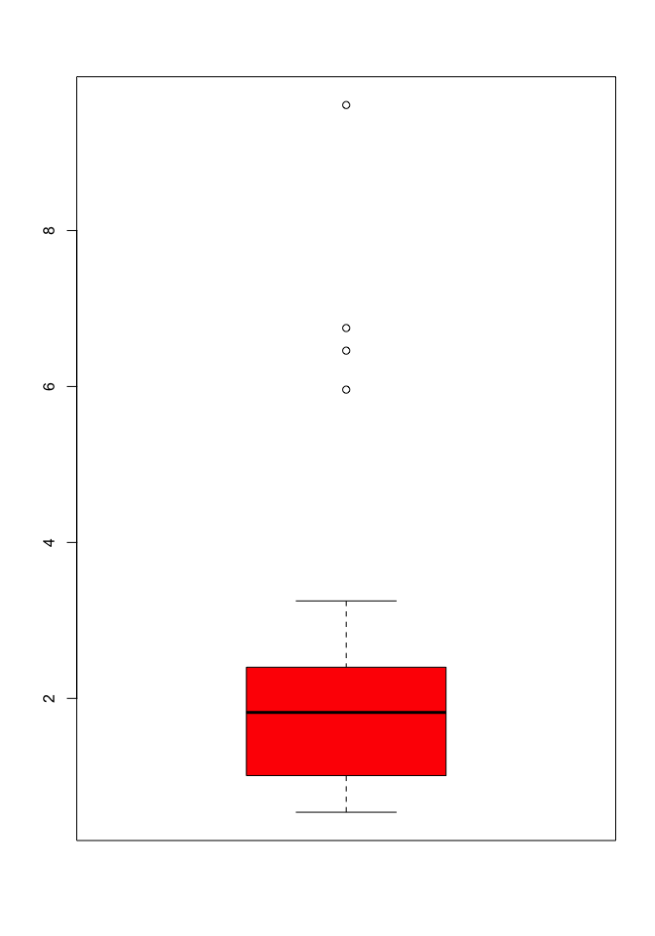

Note that the echo = FALSE parameter was added to the code chunk to prevent printing of the R code that generated the plot.